Program-12 hill cipher in c

#include <stdio.h>

#include <string.h>

int main() {

char plaintext[100];

int key[2][2];

int i, j, len;

printf("Enter a 2x2 key matrix (4 integers separated by spaces): ");

for (i=0;i<2;i++){

for (j=0;j<2;j++){

scanf("%d",&key[i][j]);

}

}

printf("Enter the plaintext (in uppercase): ");

scanf("\n%s", plaintext);

len = strlen(plaintext);

if (len % 2 != 0) {

plaintext[len] = 'X';

plaintext[len + 1] = '\0';

}

for (i = 0; i < len; i += 2) {

int x = plaintext[i] - 'A';

int y = plaintext[i + 1] - 'A';

int encrypted_x = (key[0][0] * x + key[0][1] * y) % 26;

int encrypted_y = (key[1][0] * x + key[1][1] * y) % 26;

printf("%c%c", (char)(encrypted_x + 'A'), (char)(encrypted_y + 'A'));

}

/*

int modInverse(int a, int m) {

a = a % m;

for (int x = 1; x < m; x++) {

if ((a * x) % m == 1) {

return x;

}

}

return 1;

}*/ //decryptions

printf("\n");

return 0;

}

Output:

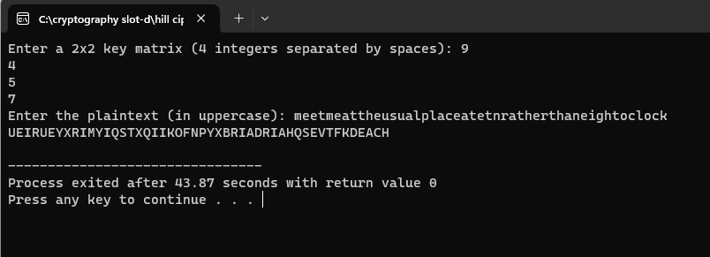n